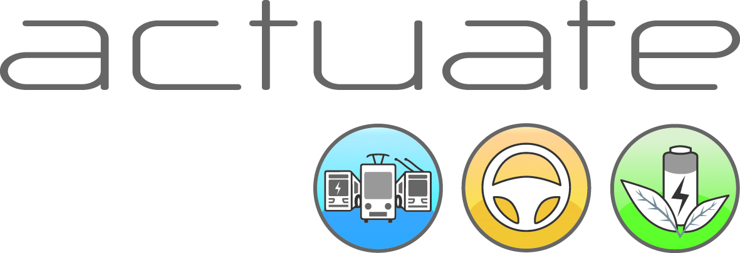

Passengers appreciate eco-friendly driving on public transport vehicles and accept longer journey times

New findings: According to a recently conducted survey amongst 5000 public transport travelers in Leipzig (Germany), Brno (Czech Republic) and Parma (Italy), 80% said that they appreciate the efforts by their local operating companies to train staff on environmentally-friendly and economically-efficient driving methods. (In Parma the level of approval was even 96%!) From those surveyed in all three cities, two thirds would be willing to accept a slightly longer journey time in order to save energy and enhance sustainable mobility.

Since May 2012, the EU-supported „ACTUATE” project has conducted eco-friendly training sessions for drivers of electric public transport vehicles such as trams, trolleybuses or hybrid buses with supercaps. Additionally, relevant data and statistics have also been collected. Dr. Wolfgang Backhaus of Rupprecht Consult GmbH explains: “The project results have shown that all partner operators have been able to save significant amounts of money, reduce pollution and enhance passenger comfort by introducing energy-saving driving styles. Up to now, over 1000 drivers have been trained.”
Passengers accept 2-minute slower journey time for the sake of the environment
During the recent survey, the majority of 5000 people answered with a resounding “yes” when asked if they would be willing to accept a slower journey time in order to accommodate an eco-friendly and safe driving style. Up to 2 minutes of slower travel time were considered as acceptable. This decisive level of public support for the concept and practice of eco-driving was quite a positive surprise for the public transport companies which queried their customers.
The municipal operator Trasporti Pubblici Parma (TEP) even developed a brand-new image campaign to emphasize the environmental benefits of eco-driving throughout the city. The overwhelmingly positive responses by travelers in Parma – 82% would accept a slower journey time and 74% generally consider eco-driving to be important – indicate that the image campaign had a positive effect and gave TEP a real PR boost.
Wolfang Backhaus adds on: „The training sessions and associated implementation of newly-learned driving skills will help save thousands of Euros per year and vehicle. Additionally, the feedback from all the drivers that participated in the sessions has been very positive. Many stated that the emphasis on “looking ahead” and pro-actively anticipating traffic situations helps them to reduce stress on the job. The added value of this health benefit cannot be underestimated, as traditionally public transport operators are faced with high sick leave rates for their drivers. Eco-driving just might be one way to counter or reverse such circumstances.”
Conclusion of the ACTUATE project: New findings must be integrated into general public transport planning
The initial project results have confirmed that energy-savings, operational cost reductions as well as passenger safety improvements and comfort enhancements are possible through the application of eco-friendly driving methods. As a next step, public transport companies must integrate this new level of knowledge into operational planning and budgeting. These efforts need to include timetable adjustments, vehicle allocations and onging staff training. All of the detailed ACTUATE project results will be presented during the 4th International E-Bus Conference in Hamburg on 17 and 18 November 2014.

Abstract:
The ACTUATE consortium consists of the five public transport companies in Salzburg, Austria (Salzburg AG), Brno, Czech Republic (DPMB), Parma, Italy (TEP), Leipzig, Germany (LVB), and Eberswalde, Germany (BBG). All of these municipal operators run electric vehicles such as trams or trolleybuses. Additional project partners are the Leipzig training and education center LAB, the Belgian bus builder Van Hool and trolley:motion, the international action group to promote innovative electric bus traction without emissions. The ACTUATE project has been coordinated by Rupprecht Consult GmbH from Germany.

Every public transport company can benefit from the concepts of environmentally-friendly and economically-efficient driving styles and apply these through training sessions and driver education on site. It is possible to subscribe to the ACTUATE project newsletter free of charge at www.actuate-ecodriving.eu . All of the project results plus statistical data will be published through the newsletter.

